Planning for change with the Think-Do-Feel Table

Transcription of narration for the PowerPoint file.

Opening screen
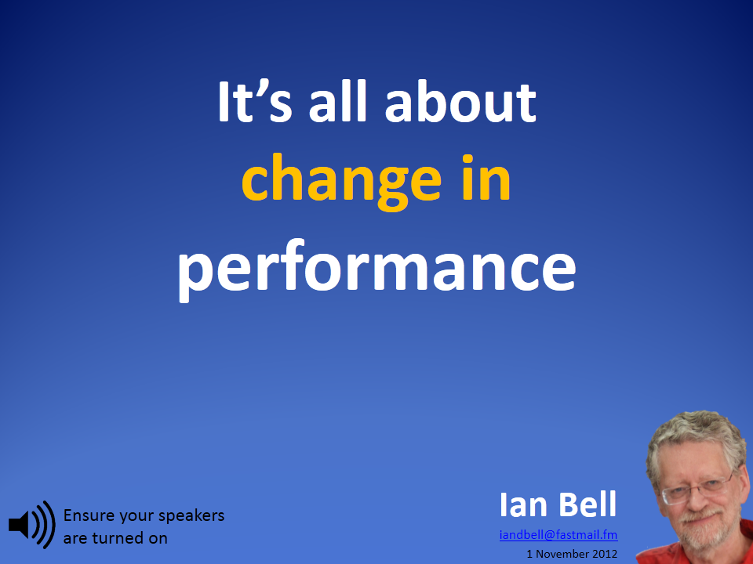 | Hello, I’m Ian Bell. Welcome to this session on planning for change with the Think-do-feel table.  Successful training means that we train for performance. In particular, we need to focus on the changes in performance we want to bring about for our learners.  Sometimes our presentations or training sessions are not as effective as we would like them to be.  One reason for this can be that we have focused on content instead of performance.  This is particularly so when we see the aim of our session as, “I’m going to tell them about this topic, tell them what I’ve done, etc.”  The simple, easy to use tool that we will consider here, helps us to move our focus away from content to change.

3. Plan for change
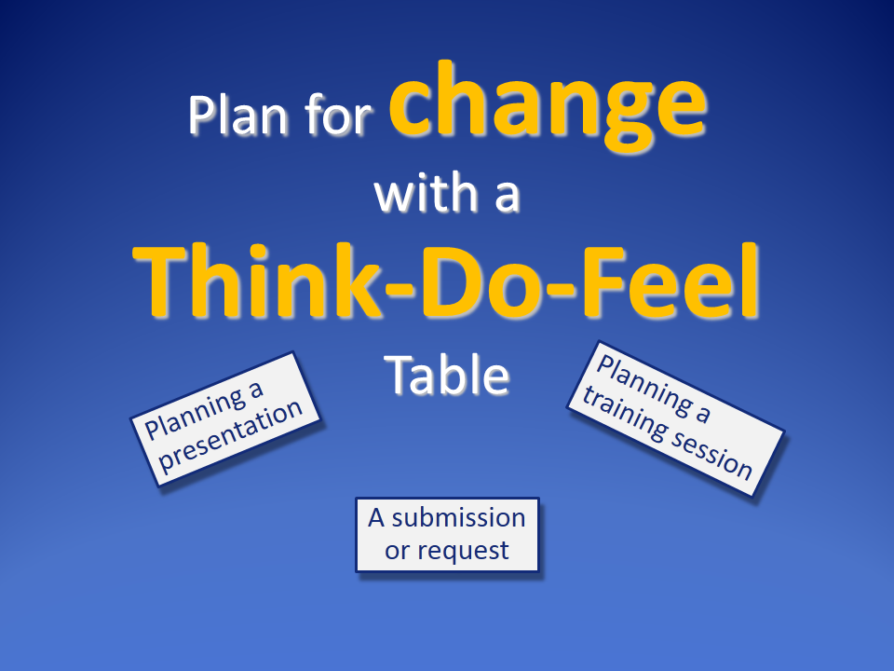 | To help your planning, I recommend using a think-do-feel table whenever you are conducting training, giving a presentation or making a request.

Andrew Abela
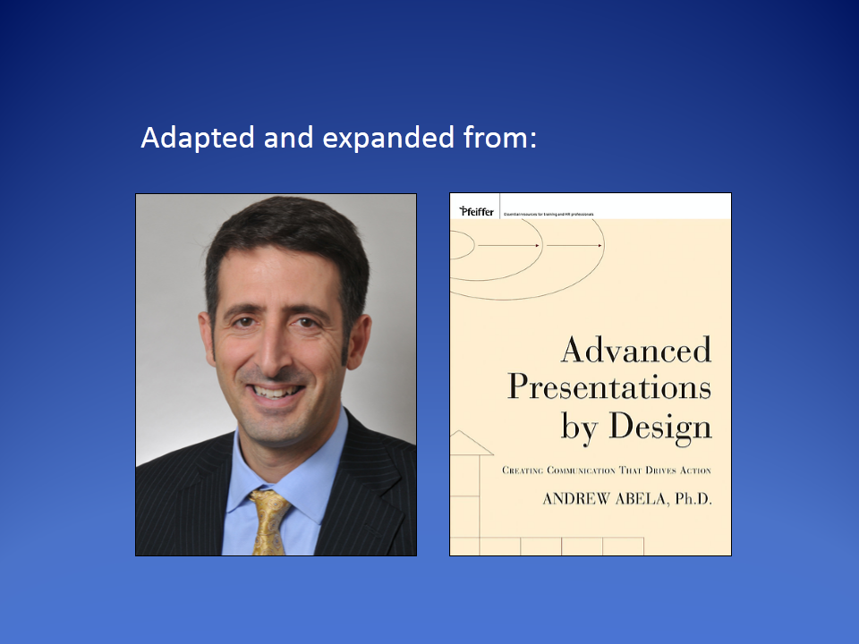 | The original idea comes from Andrew Abela, but I have expanded and extended it

Exercise: your topic
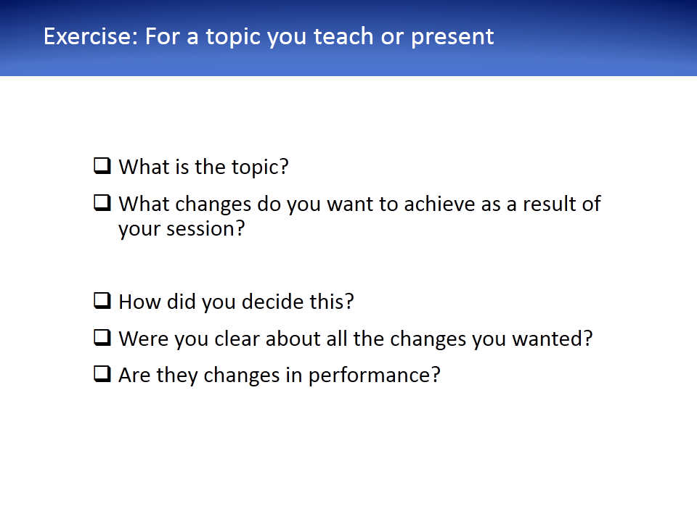 | Before we get into the details, you will find that you gain a lot more from this session if you apply these ideas as we go.  So, before you go further, consider a topic that you present or teach.  Write the topic on a sheet of paper, along with what changes you are trying to achieve as a result of your training.  We will use this topic for further exercises during this session.  When you have finished, reflect on your process.  How did you make the decision?  Did you have an informal or a systematic approach?  Were you clear about the changes you want? Are they changes in performance?

One systematic approach
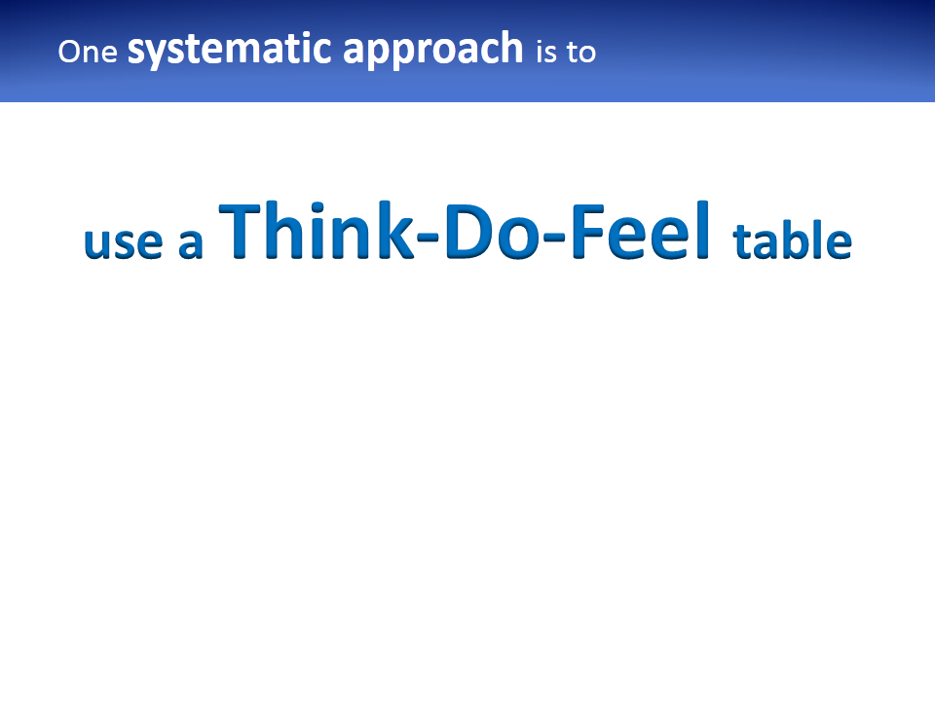 | One systematic approach is to use a think-do-feel table.  Keep your session topic in mind as we look at this.  I’ll ask you to repeat the exercise at the end of this session.

Identify changes
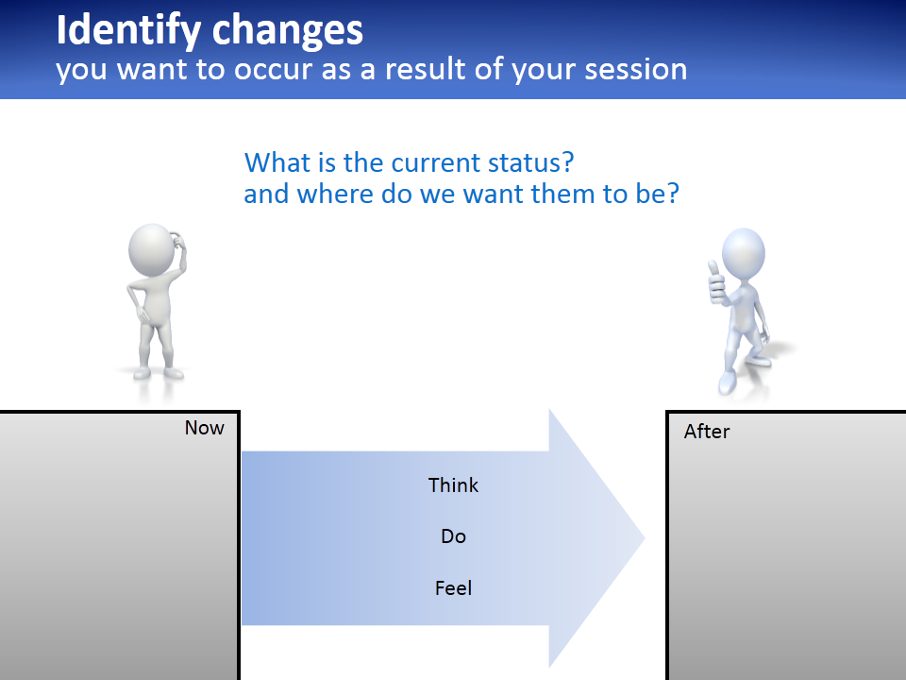 | To identify the changes we require, we first need to identify what our audience is thinking about this topic now.  Also, what they are doing now and how they feel about it.  Next, how do we want them to think, act and feel after our session?  Alternatively, you may prefer to start with the end result – how you want them to be – and work backwards to their current situation.  It doesn’t matter where you start. In practice it will usually be an iterative process.

Capture these ideas
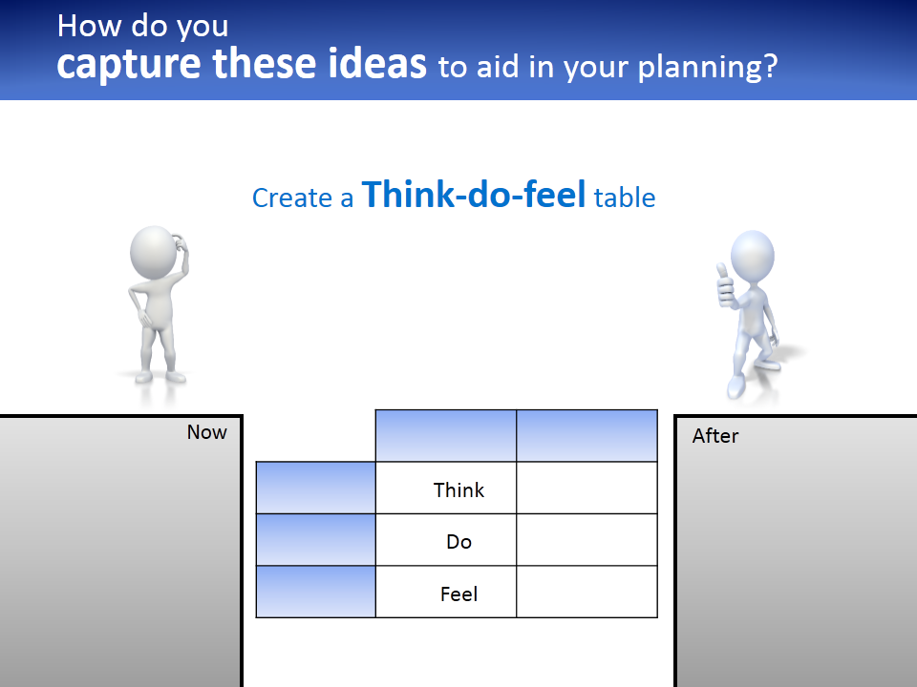 | These ideas can be captured with a think-do-feel table.  This helps you to focus on your learners as well your desired outcomes.  It shows the gap between the situation as it is now and how we want it to be.  This is something we can train for.

The table
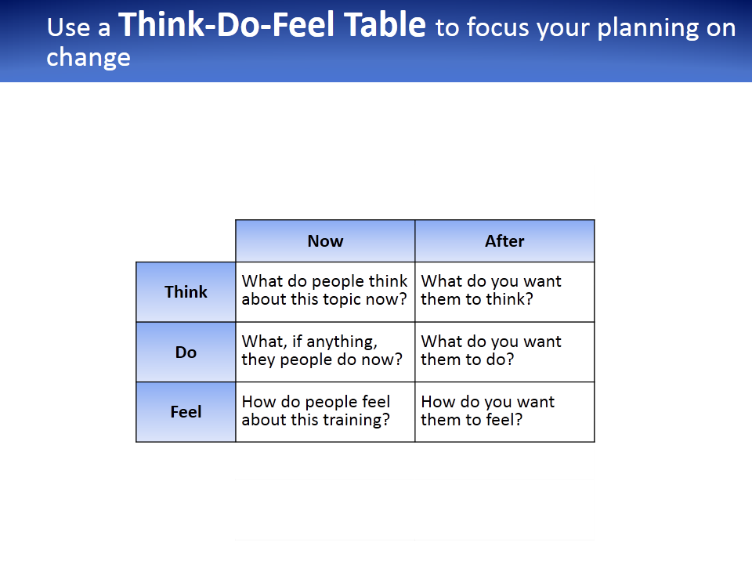 | How do you want them to change what they think?  What do they think now? Do they have preconceptions?  Do they have misconceptions that you will need to take into account? If they do, or some of them do, you will need to take this into account when developing your strategy.  What do they do now and what do you want them to do after your session? This is the performance.  And how do they feel about this topic? Are they positive or negative about this subject and your training or presentation? Are they motivated?  You will need to take into account all of these things when planning your training or presentation.  We’ll have a look at some examples in a minute.

Heterogeneity – multiple starting points
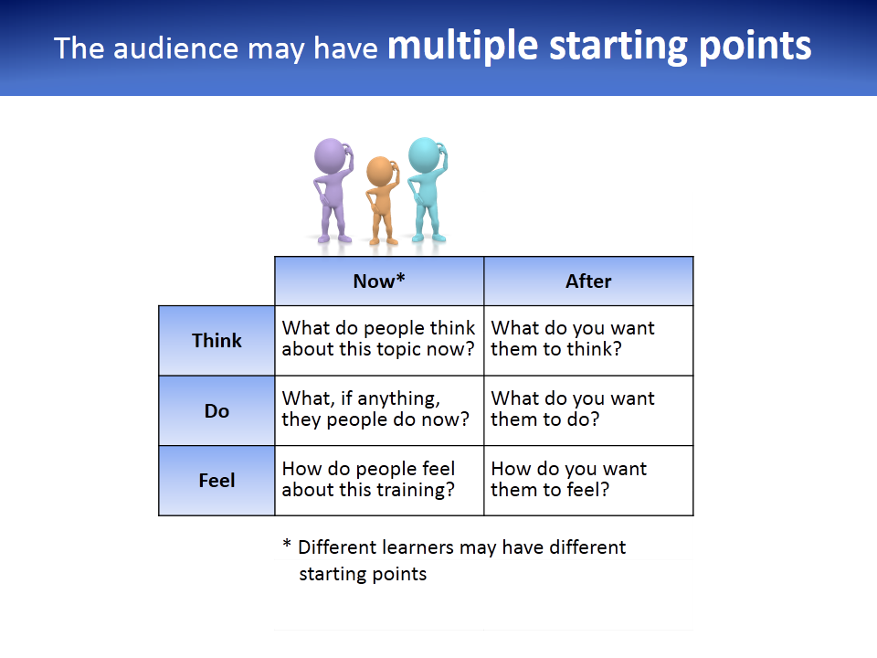 | Sometimes your audience may be homogeneous, especially if the topic is entirely new to them.  However, most often there will be a range of initial states, some of which may be conflicting.  These will be recorded in the “Now” column.  You will need to adjust your session accordingly.

Possible examples
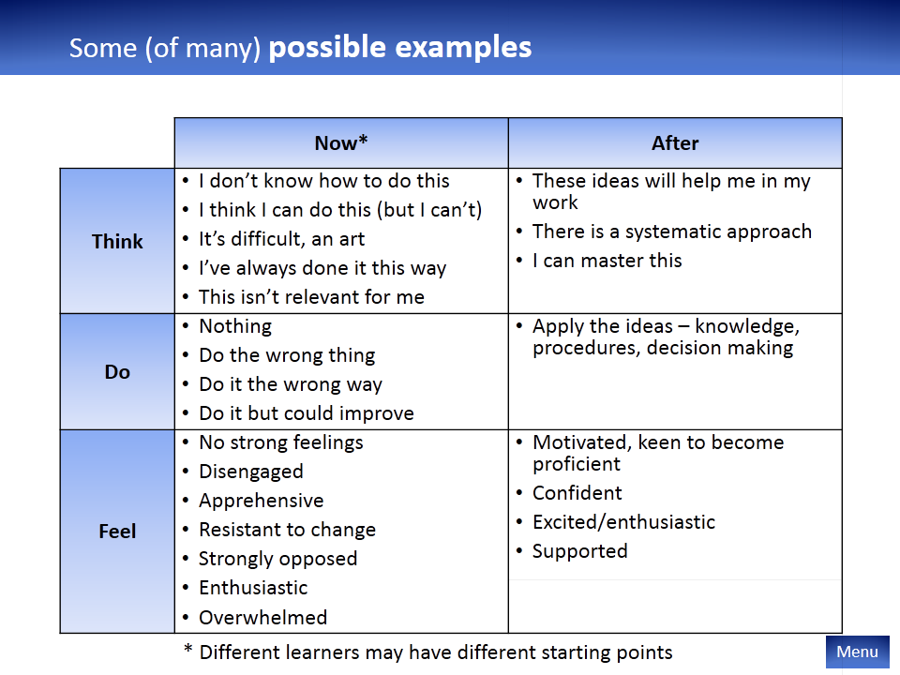 | Here are some examples of the sorts of changes we could be looking for. Of course, each case will be different.

This session
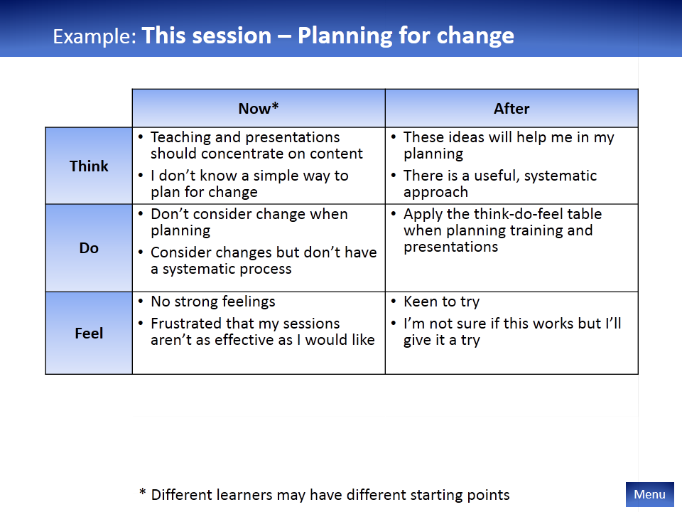 | Here is a think-do-feel table for this session.

Your topic
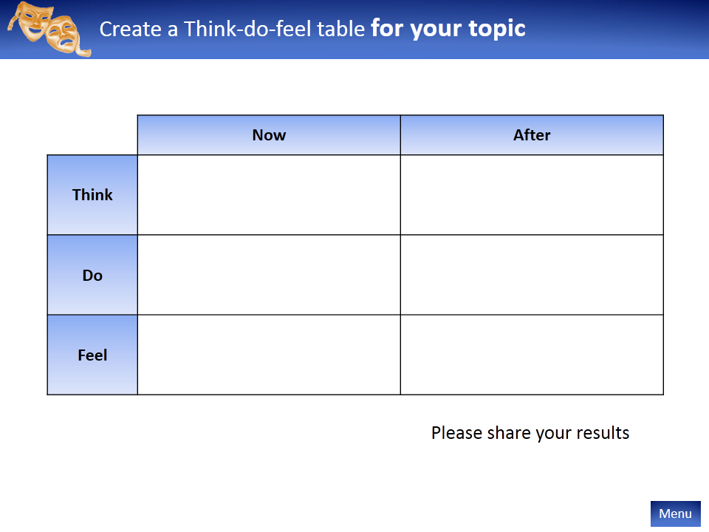 | Think back to your topic and have a go at filling in the table. You may like to type it into the Word document.  The accompanying Examples PowerPoint has many more examples to give you some ideas.

Bring about change
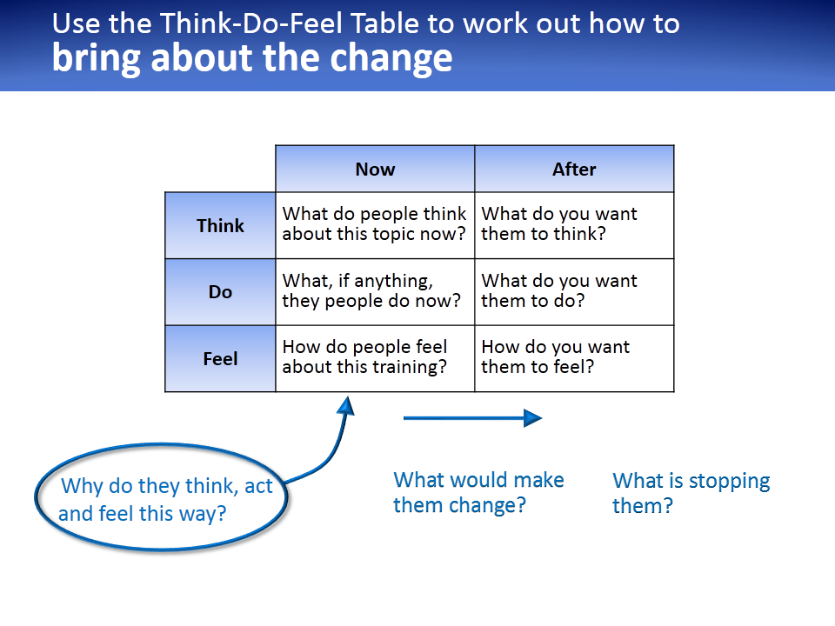 | Now that we have the table, we have identified the changes we want. But what do we do with it? How do we use it to plan our session?  We need to consider why they are the way they are now, what would make them change and what is stopping them changing.

Why do they think and act this way?
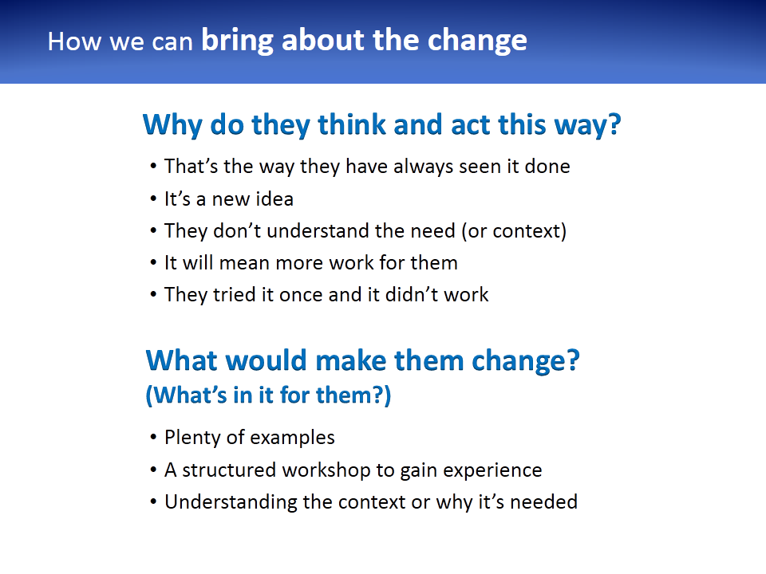 | Here are some examples. Again, remember that each situation is unique.

Your topic
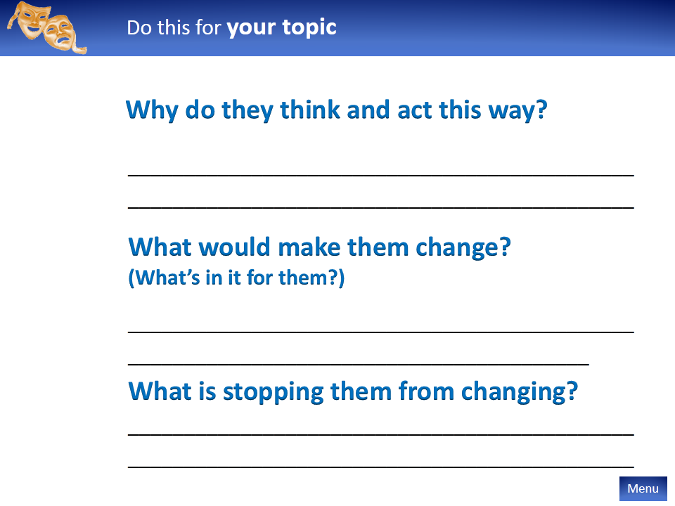 | Consider your topic. Why are they how they are now? What is in it for them to want to change? What is stopping them?

Please share
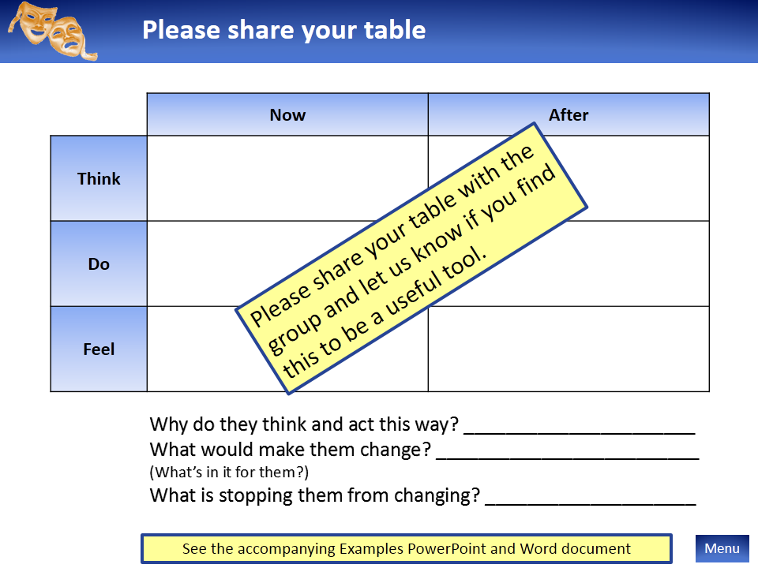 | When you have completed your table please share it with the group so we can all learn.  Let us know how you found the process.  If you are uncertain how to do it please provide as much information to the group as you can and we will help you through the process.  If you have another tool that you use for this aspect of training planning please share it with us.  Thank you all for your attention.

Please also see the accompanying Example PowerPoint and the Word template document.

