Meteorological simulator user guide

*V2, 18 Mar 2025*

Contents

[Introduction 3](#_Toc201767265)

[Preparing your images 3](#_Toc201767266)

[Naming the image files 3](#_Toc201767267)

[Building the directory structure 4](#_Toc201767268)

[Building the SIM 5](#_Toc201767269)

[Welcome screen 5](#_Toc201767270)

[Define data types 6](#_Toc201767271)

[Adding products from your file system 7](#_Toc201767272)

[Adding products from WMS 9](#_Toc201767273)

[Define tasks 11](#_Toc201767274)

[Download and test your SIM 13](#_Toc201767275)

[Running the SIM 14](#_Toc201767276)

[SIM modes 14](#_Toc201767277)

[User Interface 16](#_Toc201767278)

# Introduction

This is a short guide on how to use the EUMETSAT Simulator Creator for building your own weather simulators.

Simulators can be used for a range of tasks — EUMETSAT predominantly uses them for operational meteorology training. The example presented here is from weather forecast training, but it can be used for many other applications. If you would like to share your application message us at training@eumetsat.int.

The simulator is a simple web-based application where the user (often the weather forecaster) will work on a weather case, using an interface resembling a weather forecasting environment. The wall clock runs (you can set it to run very fast!), data keeps on appearing as the time progresses, tasks appear, and the user needs to focus on diagnosing the case and working with the available limited data to create actual forecasts.

The simulator version presented here is a simple interface meant to help the forecaster to focus on essential components in forecasting: the rhythm of a forecasting shift with possibly a briefing in the beginning by the session lead, some forecasts prepared and, maybe, amended during the shift, and in the end verifying the results. How much material to add into the exercise is up to the designer of the SIM. The more material you want to display, the more there is work for you as a creator in preparing the imagery. However, often the main elements of a forecasting challenge can be achieved with just a few key datasets.

The SIM Creator runs in the [**European Weather Cloud**](https://europeanweather.cloud/), it is freely available (no login needed). Crediting EUMETSAT is appreciated.

The simulator tool has developed over many years and the experiences and feedback of the Eumetcal community have been essential in its development.

# Preparing your images

Acquiring the images for the simulator exercise is the most elaborate part of SIM building. This guide will not cover this part in detail, but only give guidance on naming and organising the images.

Generally, if you intend to run the SIM over the internet, be aware of the file sizes, creating the file sizes rather kB size than MB size. Otherwise, the SIM will not run effectively over the internet.

Keep your image dimensions suitable for screen reading. For an illustration, images 1024x768px fit better on screen and require less scrolling than larger images.

You will find a [**zipped sample set of images**](http://training.tools.eumetsat.int/sims/training/sampledata_new.zip) (800x599px) to see the preferred image organisation in folder. You can use these images to practice building a SIM, along with the instructions in this guide.

### Naming the image files

The images that you prepare elsewhere must follow the naming convention. This applies to all images, no matter observational or prediction data. The name must be in the format:    
yyyy-mm-ddThh.mm.ssZ.gif (or.jpg or.png)

For example: 2022-05-25T11.10.00Z.jpg /gif/png

## Building the directory structure

In order for the simulator to be able to use your images, they must be in gif, jpg or png format.

Later in the actual simulator editor, you will explain to the system how you want your images to be organised. Look at the layout example below:

Figure 1: Data types and products layout in the simulator.

On top row you can see **data types**, for example satellite, NWP, surface or other data types. On the second row, you can see **products** belonging to each data type. Note that if your SIM will contain consecutive NWP model runs, you need to include each model run as an individual data type (see the example in Figure 1).

Hence, before building your SIM it is a good practice to organise your images in the same manner in your file system. Below you can see an example matching the menu items above. You add your satellite images into the folder named Satellite, each product into its own sub-folder (in this example IR108 and Natural Colour RGB). The same applies to the individual NWP model runs: in this example we will use two consecutive AROME model runs, 06:00 UTC and 12:00 UTC run. For overlays, add all your overlay parameter directories directly into that. The overlay parameter sub-directories shall NOT contain further subfolders.

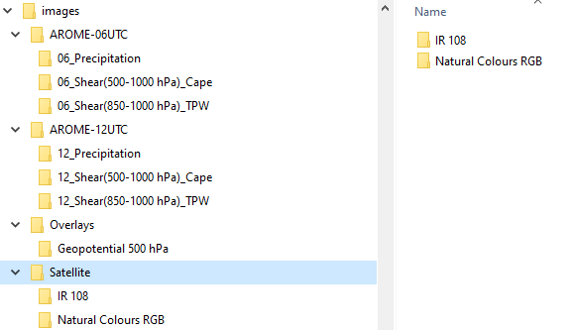

Figure 2: Organisation of the data directories on computer

# Building the SIM

Access the simulator creator at <https://sims.trainhub.eumetsat.int/welcome>

The following sections describe in detail what each area of the Simulator Creator contains.

## Welcome screen

Choose 'Create a new simulator' if you are creating a new SIM or 'Modify a simulator' if you have an existing SIM that you want to update.

Clicking at 'Create a new simulator' will take you to the Splash screen (see next section).

Clicking at ‘Modify a simulator' will request you to drag and drop **two**.js files into an existing simulator; these are ‘model.js' and 'overview.js’, which you will find in your existing simulator 'data’ directory. You will then be forwarded to the Splash screen.

#### Define Splash screen

Add or edit the essential basic information:

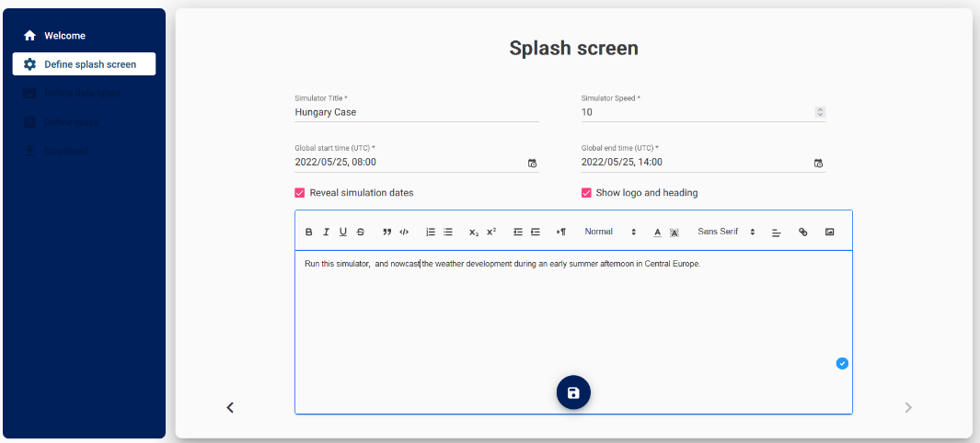

Figure 3: The Splash screen

* **Simulator Title**
* **Simulator Speed** — the number you enter will define how fast the simulator will run. For example, if you set the number to six, the simulator will run six times faster than reality, meaning that 60 minutes (one hour) of real time will last 10 minutes in the simulator. Choose the time according to what you want the learners to achieve, and how much time for briefing and debriefing you want to allocate.
* **Global start time (UTC)** — this is the time when the simulation begins, the clock will start at that time.
* **Global end time (UTC)** — this is the time when the simulation ends.

You can choose to reveal simulation dates or not. This is useful when you want to hide the exact date when the event took place. You can also choose to hide the logo and heading on top of the screen to save space.

The text you provide in the text box will be a description of your simulator. You can include a description of a case, introduction, or you can add an image of the area, shift schedule, etc.

After finishing with your input, click on the SAVE sign and move to next screen.

## Define data types

The next step is for defining data types. Data types are meteorological data, for example satellite or surface observations, NWP model runs, etc

 You add a new data type by clicking at dark blue plus sign.

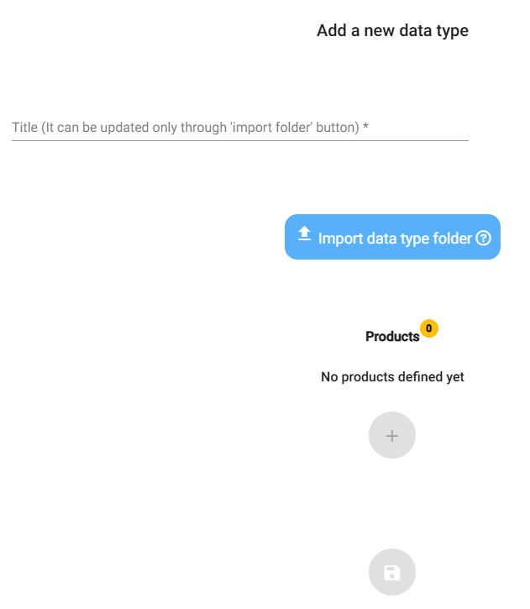

Figure 4: Adding new data type

Let’s assume you want to start by adding a Satellite data type first. Start importing the Satellite data type by clicking at blue button ‘Import data type folder’ (Figure 4). Locate the folder where your satellite data is located, click ‘Upload’ and click again ‘Upload’ in the dialog box that appears (Figure 5).

Figure 5: Confirming the upload of images into the SIM creator

A dialog box with the message ‘Only data type folder name is considered’ will appear, click OK.

You will notice that the Data type is automatically named according to the directory name. This will ensure the folder names in the simulator will be correctly named.

Each data type can contain one or more **products** (see Figure 1). For example, 'Satellite' can have products such as 'IR', 'Airmass RGB', 'CRR', etc. NWP model runs type may contain products such as 'CAPE', 'MSL', 'Z500', etc, according to the imagery you have prepared. The products appear as second row menu buttons when the user runs the simulator.

 Start adding products for the data type of your choice by clicking at the plus icon.

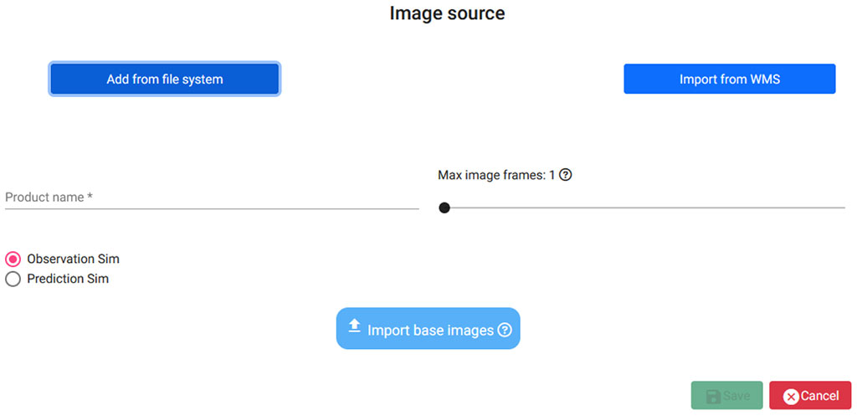

Figure 6: Adding the products

Here you have a choice between adding products from your local file system or from a WMS.

### Adding products from your file system

Let’s assume that you want to add some products into Satellite type. Satellite data is observational data, so keep the Observation Sim choice selected. With this choice, the observations will appear one after another, as the time progresses, in the same way they would appear in reality. You can choose the number of past images that the user will be able to see by choosing Max image frames, for example, if you choose 10, the user will be able to see up to the 10 latest images.

Clicking on 'Import base images' will open the File selector where you will be able to navigate to the folder on your computer, where you have stored your products. Point to folder containing the desired product to be added and click 'Upload' and confirm your choice (Figure 7).

Figure 7: Confirming the product upload

Again, note that the product will be automatically named according to the directory name. Be sure you have correctly named the files in the folder before adding them (naming convention yyyy-mm-ddThh.mm.ssZ.gif /jpg/png).

The preview of the included files will show you whether the images are valid (Figure 8).

Figure 8: Output of correctly included images

Once you have selected the base images, you may also wish to add some overlays to toggle on and off on the base images. The example in Figure 9 shows how you can add various overlays. In this example the user has 32 base images (15-minute satellite observations for eight-hour period) with a possibility to toggle a three-hourly NWP forecast field of 500hPa geopotential height (nine images), and with an option to toggle a location pin on or off.

The number of overlays does not need to match the number of base images. The SIM creator will show a new overlay when the base image time matches it, and, otherwise, keep on showing the latest available overlay image. Having only one overlay image in one overlay folder will simply keep on showing it throughout the simulation, allowing us to include check boxes for geographical data, coastlines, legends, etc, when needed.

Just like the base images, also the overlay images must be named in the same convention yyyy-mm-ddThh.mm.ssZ.gif /jpg/png.

Figure 9: Adding overlay images. In this example, the user has added an overlay (Geopotential 500hPa folder containing nine three-hourly NWP forecasts and one static background image)

Adding (NWP) model run data is very similar to adding observational data. However, when adding model data, you must remember to choose ‘Prediction Sim’ instead of ‘Observation Sim’, see Figure 10.

Figure 10: Adding model data requires choosing ‘Prediction Sim’ instead of ‘Observation Sim’

After you have finished adding observation and model data types and products, you can proceed to the next display for defining tasks.

### Adding products from WMS

You can also use certain viewing service sites (Web Map Services) and let the SIM creator extract the image data directly from there, without creating the imagery at your end. The benefits are obvious — much less production time needed for creating the imagery. The disadvantage is that the SIM connects to the WMS while running, therefore, retrieving the imagery makes the interface somewhat slower, depending on the connectivity. Strong and stable internet is required to use a SIM like this in a classroom environment. If you are not sure you will have an internet connection while running the SIM, avoid using WMS layers.

In the example below (Figure 11), we use the **[EUMETView WMS service](https://view.eumetsat.int/productviewer?v=default" \t "_blank)** to retrieve the imagery.

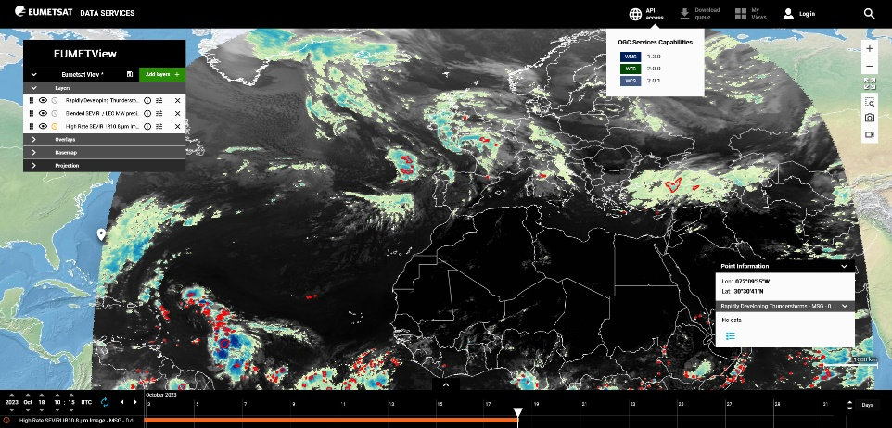

Figure 11: EUMETView API access button

Go to EUMETView and click the API access button at top of the page, and then click at WMS 1.3.0. An xml page will open, where all the essential data needed for the SIM is available.

Look back at your SIM Creator screen with Import from WMS menu showing what data is needed (Figure 12):

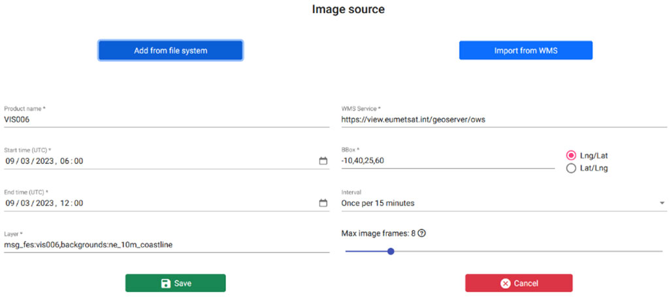Figure 12: WMS Menu

* **Product Name**: The parameter name you want to show in SIM
* **WMS Service**: You find this on top of the xml file:

<Get>

<OnlineResource xlink:type="simple" xlink:href="https://view.eumetsat.int/geoserver/ows?SERVICE=WMS&"/>

</Get>

Start time and End time in UTC

BBox: The bounding box to display in SIM, in bottom-left, top-right. Choose the order of LON or LAT as you wish.

Interval: image interval

Layer: pick the layer from xml file. For example, VIS 0.6 microns product can be found at

<Layer queryable="1" opaque="0">

<Name>msg\_fes:vis006</Name>

<Title>High Rate SEVIRI VIS0.6 μm Image - MSG - 0 degree</Title>

You can add coastline by finding

<Layer queryable="1" opaque="0">

<Name>backgrounds:ne\_10m\_coastline</Name>

<Title>NaturalEarth Coastline</Title>

yielding to a final parameter input in Layer as:

msg\_fes:vis006,backgrounds:ne\_10m\_coastline

Save to continue to the next display.

## Define tasks

In this display, you can add tasks into your simulation to engage people with the data, with forecasting actions, or other job-related challenges. The tasks will appear during the simulation at a desired point of time.

You can add several tasks for your simulation. The user will see a notification in their left panel when new tasks are sent.

There are three ways to introduce tasks:

Add URL

Type in the title for the task and the time (in UTC) when the task shall appear. Add and edit the URL or the Description, and click save, see Figure 13. This task will open a new tab on an external site, such as an online form or questionnaire. In the actual Simulator the task will be shown in the user interface with a little red symbol (Figure 14).

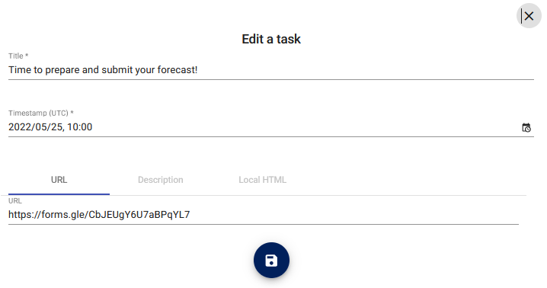

Figure 13: Adding a task, in this example the task will be filling a forecast in an online form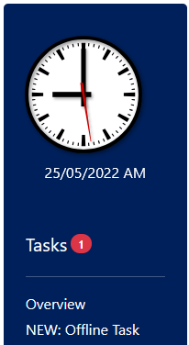

Figure 14: Task appearing in the simulator

Description

This will open a popup window on top of the current window, for example with written task instructions or guidance (Figure 15).

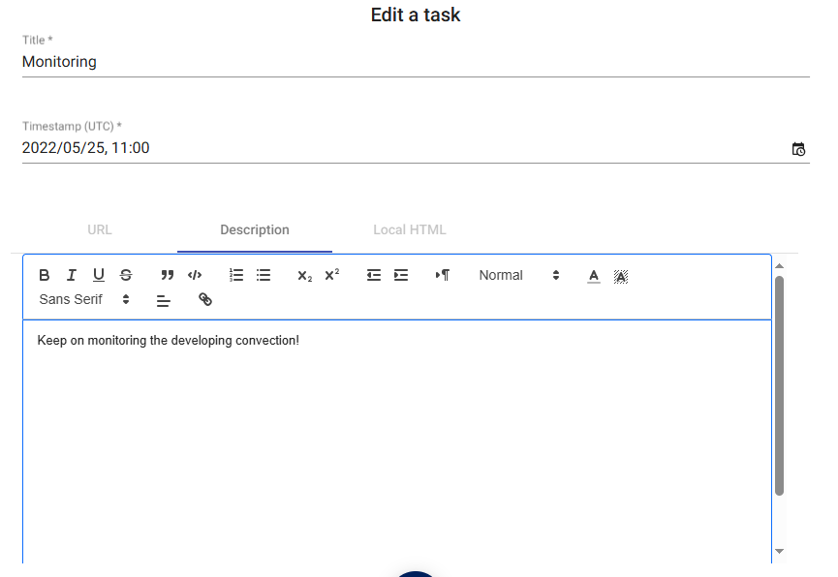

Figure 15: Adding a description task to SIM

Local HTML

This allows the user to add a local HTML file. This is suitable for offline environment and when you want to have more flexibility in creating the task. See the instructions on where to place the HTML file before running the simulation engine (Figure 16).

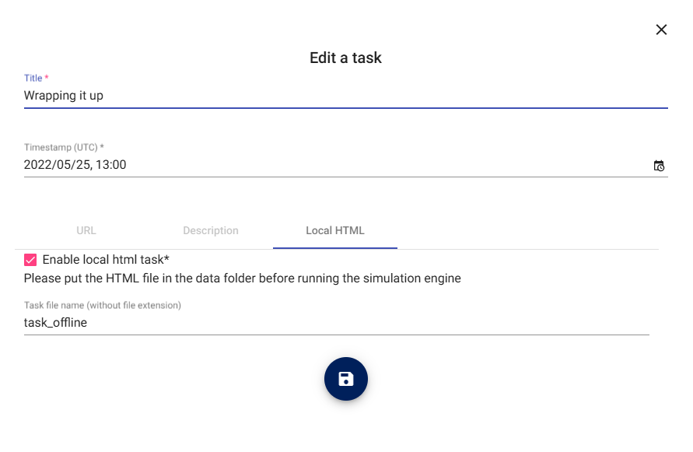

Figure 16: Adding a local HTML task to SIM

## Download and test your SIM

This is the final stage in making your SIM. Once you have completed your SIM structure with data types, data products, and tasks, you can download the structure as a zip file. Save it on your computer.

Remember, **during the SIM building you have NOT moved any data files and directories across the internet**, but instead only worked on the SIM structure/model. Now that you have your SIM zip downloaded, it is time to insert your data files into it and run it (unless you have used WMS for image retrieval).

**Unzip** your SIM zip into your computer. You should see something like this:

Figure 17: Unzipped contents of a simulator file

If you investigate 'data' folder, you will see it is almost blank:

Figure 18: Data folder initial content

Tobring your images into the SIM,**MOVE** your images into 'data' folder. As a result, you will see something like this:

Figure 19: Data folder content after moving the images

**TEST** the SIM by going one step up, locating the index.html file and opening it:

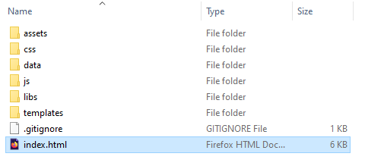

Figure 20: Locating the index.html for testing the SIM

That’s it!

If you want to know how the **code** works, you can easily find out how to make tweaks to your simulator even without opening the SIM creator, just by editing the **model.js** file, which you will find in **data** folder.

# Running the SIM

The fun part of the SIM is to use it in instruction. SIM exercises are often part of classroom course hands-on practical sessions, but can also be introduced in online training or as a self-study practice. This section describes some details to keep in mind when running the SIM, in order to make the sessions more engaging and instructional.

### SIM modes

Depending on the needs, simulators can be run in various ways: locally on computer or handheld device, or via an internet site.

#### Running the SIM locally

You can copy the SIM files onto a USB stick and run it on any computer. Remember to ensure the data type and product directories with their images are copied into the 'data' directory of the unzipped SIM file, before copying to the USB. Before copying, check that the SIM works (the data paths are correct). The user always runs the SIM by pointing their browser to index.html.

#### Running the SIM on a server

If you have a training server, or a LMS (ie, Moodle) available, you can upload the SIM (with its data in it) onto the server and point the users to the index.html to run the SIM. If you like to run the SIM in Moodle, first zip the whole SIM with data, and upload the zip onto your page:

Turn Editing On - > Add a resource…File -> select the zipped file.. and once uploaded, click the file in Select files window to pop up the options (see Figure 21).

Figure 21: Inserting your SIM to Moodle environment

Choose ‘Unzip’ and you will see the unzipped contents of the file. Click once at index.html and choose 'Set main file'.

Figure 22: Unzip and make index.html the main file

Now your SIM will run in the Moodle.

Most issues with online version having problems showing the images, are connected with the file naming issues: capital letters and blank spaces do make a difference in the server world. Check these if your SIM does not show up.

## User Interface

For the user, the interface is simple, see Figure 23. The clock, the task, and the overview window are presented clearly. The title is embedded in the Splash picture. You can change the Splash picture in the *meta*folder. The yellow button invites the user to start the simulation. After clicking, the clock starts running.

Figure 23: SIM startup view

***Note****: It is strongly recommended that users do not change to other applications while in the SIM, to ensure the smooth conduct of the exercise. They should be careful not to use Browser Reload or backward buttons, as this may result in the exercise starting from the beginning. If this happens, the instructor can help them getting back on track using the small, nearly invisible + button at the bottom of the SIM. Clicking this opens a shortcut to jump backward or forward in the exercise.*

Good practice in SIM exercises is also to provide the learners with enough background information before they start the exercise. This may be a set of weather briefing slides presented by the session lead, or a set of slides they will read online before clicking the Start simulation button.

Verification is a part of the exercise. Verification is simply an opportunity for the forecaster to check how they did in the exercise. This can be done as a group, if in a classroom, discussing potential reasons why certain forecasts were challenging.

Working through a simulation can be quite intensive. To end the simulation session properly, a debriefing is required. In the classroom this may be an open discussion, or another way of getting feedback and let the participants voice out their feelings and experiences. A debriefing, or a feedback discussion, will help the participants to get back to normal life again, and discuss about what they learned in the exercise.