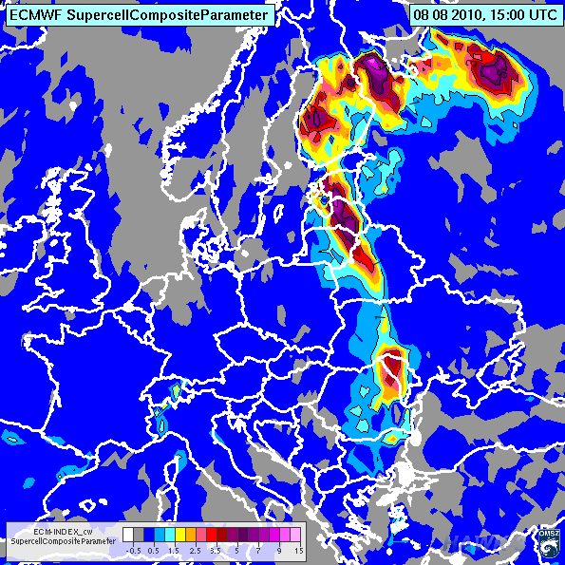

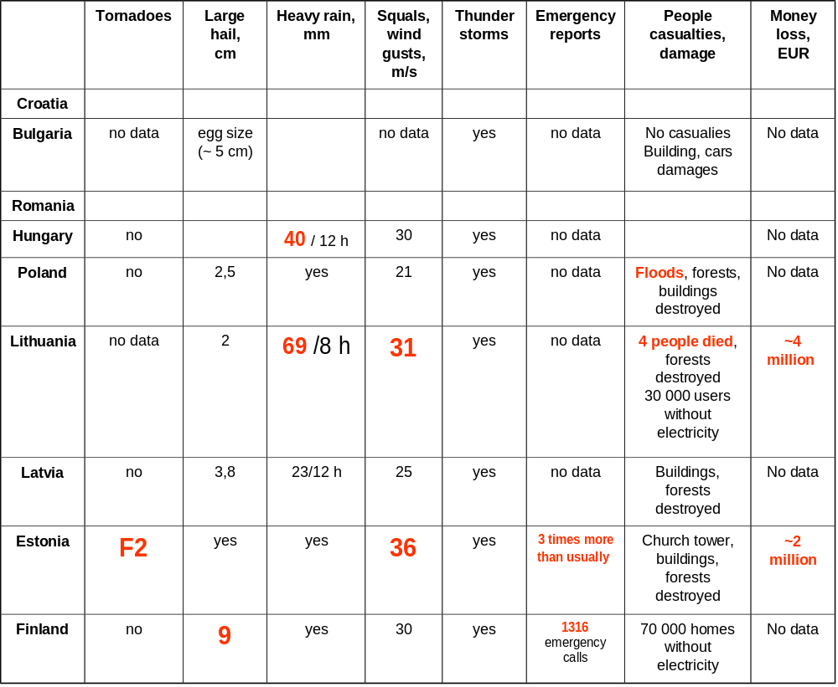

THANKS TO COLLEAGUES:
Dunja Plaèko-Vršnak (Croatia)
Mariana Popova, Gergana Kozinarova (Bulgaria)
Sorin Burcea (RNMA, Romania)
Kálmán Csirmaz, Márk Rajnai (Hungary)
Magdalena Ožka, Mateusz Barczyk
(IMGW, Poland)
Teresė Kaunienė (LHMS, Lithuania)
Laura Krumina (LEGMA, Latvia)
Helve Meitern (EMHI, Estonia)
Jenni Rauhala (FMI, Finland)

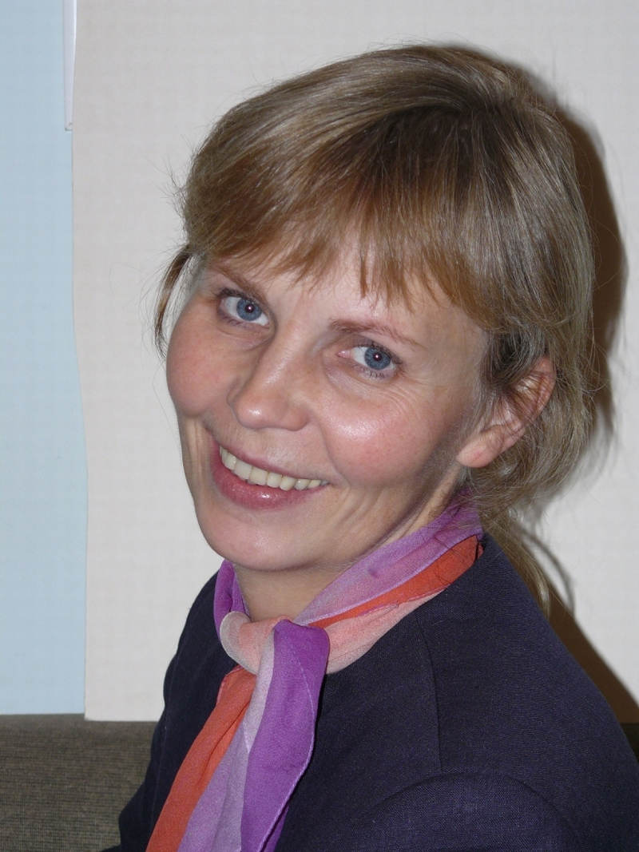
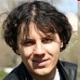
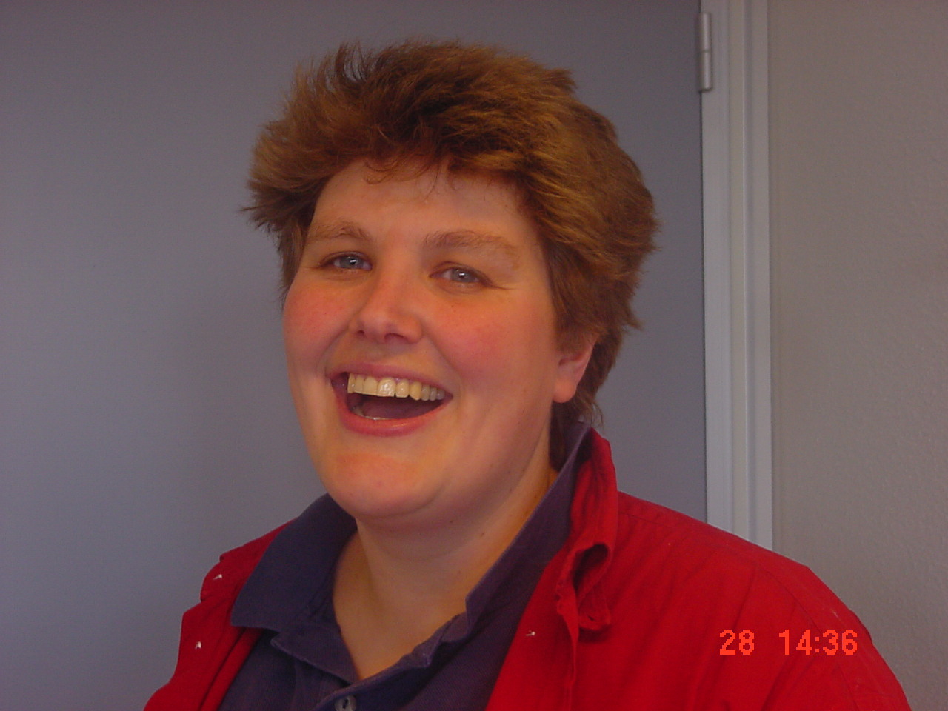
Your presenters for today’s session
Kornel
Kollath

Hungarian
Met. Service
Izolda
Marcinonienė

Lithuanian
Hydrometeorological
Service
Heleen
ter
Pelkwijk

Netherlands
Met. Service

