VLab Self-assessment – Centres of Excellence
Comparison of results 2014 and 2016

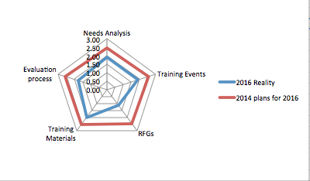

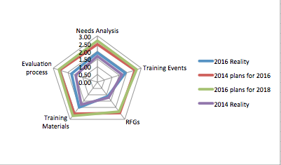

VLab Self-assessment – Supporting Agencies
Comparison of results 2014 and 2016

