VLab Self-assessment – Centres of Excellence
Results 2016

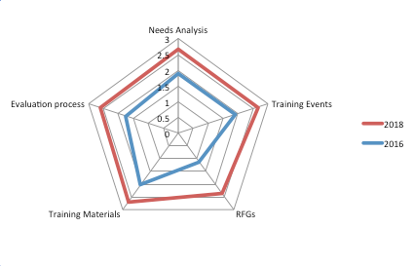

VLab Self-assessment – Supporting Agencies
Results 2016

