Hotels in Darmstadt
Arthotel Ana Victory  (8 min by taxi, close to the center)  Address:  Bleichstrasse 48, Darmstadt, Germany  Tel.: +44(0)2030265047 | B&B  (walking distance, close to the station)  Address:  Zweifalltorweg 4, 64293 Darmstadt, Germany  Tel.: +49 6151/967 20  Email: darmstadt@hotelbb.com
Best Western  Address:  Am Kavalleriesand 6, 64295 Darmstadt, Germany  Tel.: +4961517377500  Email: darmstadt@plazahotels.de | Felix Hotel Darmstadt  (5 min by taxi, close to the center)  Address:  Kasinostrasse 4, 64293 Darmstadt, Germany  Tel.:+49 6151 39 737 20  Email: darmstadt@felix-hotel.de
Holiday Inn  Address:  Dornheimer Weg 7, 64293 Darmstadt, Germany  Tel.: 0800 181 3885 | Hotel Garda  Address:  Am Pelz 2a, 64295 Darmstadt, Germany  Tel.: +49 (0)6151/130200  Email: hotel-garda@gmx.de
Intercity Hotel  (10 min, at train station)  Address:  Darmstadt Hauptbahnhof Am Hauptbahnhof, 64293 Darmstadt, Germany  Tel.: +49 6151 90691-0  Email: darmstadt@intercityhotel.com | Maritim  (10 minutes walking distance to EUMETSAT, next to the station and Airliner)  Address:  Rheinstraße 105, 64295 Darmstadt, Germany  Tel.: +49 6151 303-125 (-126)

Moxy Hotel  Address:  Georg-Ohm-Straße, 64295 Darmstadt, Germany  Tel.: +49 6151-667090 | The Darmstadt  (5 min by taxi, close to the center)  Address:  Kasinostraße 6, 64293 Darmstadt, Germany  Tel.: +49 6151 39 70 0  Email: info@the-da.de
Welcome Hotel Darmstadt  (next to Darmstadtium and city center, 10 min by taxi)  Address:  Karolinenpl. 4, 64289 Darmstadt, Germany  Tel.: +49 6151 3914 483  Email: info.dar@welcome-hotels.com | Greet Hotel  (in walking distance to EUMETSAT)  Adress:  greet hotel Darmstadt, Hilpertstraße 27, 64295 Darmstadt Germany  Tel.: 06151 397650  Email: HB6J0@accor.com

Location and Directions

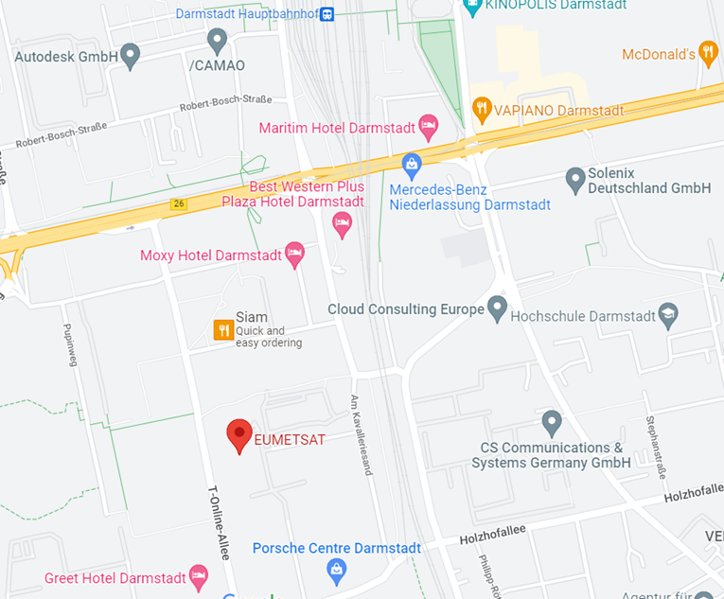
Eumetsat Allee 1
64295 Darmstadt
Germany

Taxi from Frankfurt Airport
Approximately 45 €

Shuttle bus from Frankfurt Airport
AirLiner-bus until stop "Main Station" (approximately 8,60 €)

From Darmstadt Train Main Station (Darmstadt Hauptbahnhof) to EUMETSAT
In walking distance (approximately 10 minutes)

