1./ Install conda
Conda is an open source package management system and environment management system – this is the easiest and most reliable way to manage the installation of all necessaries components. Here is the installation
Or here the direct installation of anaconda – good if you run python or start with conda
Additional doc is here
2./ You need to activate an environment that contains all libraries and versions to run properly the notebooks
You need a proper environment file that contains all libraries to be used by conda to create the environment using the right versions. Here are:
For the dust.training hub download environment_dust.yml
For the data tailor hub download environment_tailor.yml
For the RGB Casablanca hub download environment_casablanca.yml
3./ Activate the environment:
Create the environment from yml file: conda env create -f environment_***.yml

Activate the new environment

For dust you have to type: conda activate dust
For the casablanca_hub you have to type: conda activate casablanca
For the data tailor you have to type: conda activate tailor

Important – the easiest is to activate one environment – then you may deactivate if you want a new one – run conda deactivate

Verify that the new environment was installed correctly conda env list

Very often may happen that you have conflicts with your python installation – here how to manage when you have already a python installation and here a general guide to manage environments
4./ Download the notebooks and data
The easiest way is to download the files you want to use and the data as above
Important – you need to download the functions.ipynb notebook
All data are available in the eodata folder - Just check the path of the notebook to be sure to download the right dataset
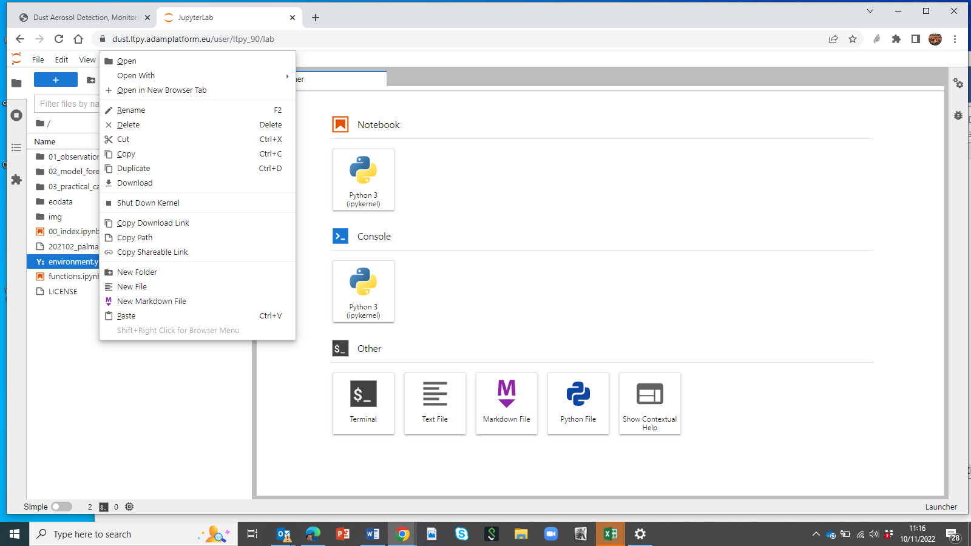
5./ Set up the jupyter lab

You also might want to install jupyterlab. See the description here. Please make sure to install it while your conda environment is activated.
Once jupyterlab is installed in a terminal, navigate to the folder, where you downloaded the notebooks and open the juypterlab interface with the following command:

jupyter lab

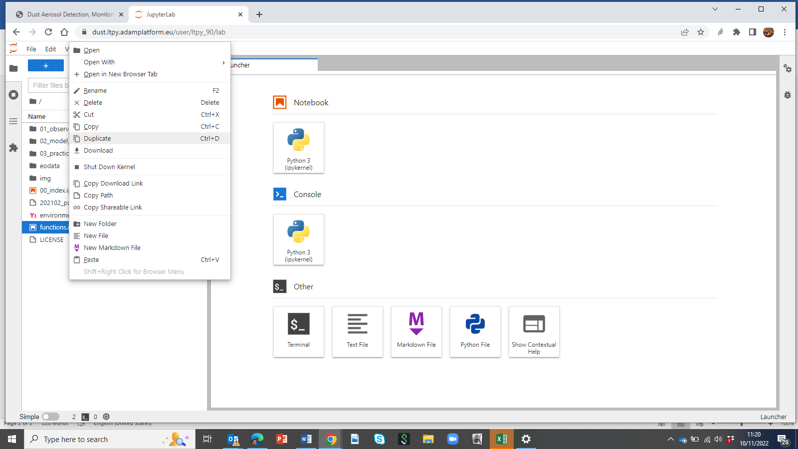

Create the environment file from the terminal
If you do not have environment file you can generate it – the option is not the recommended one
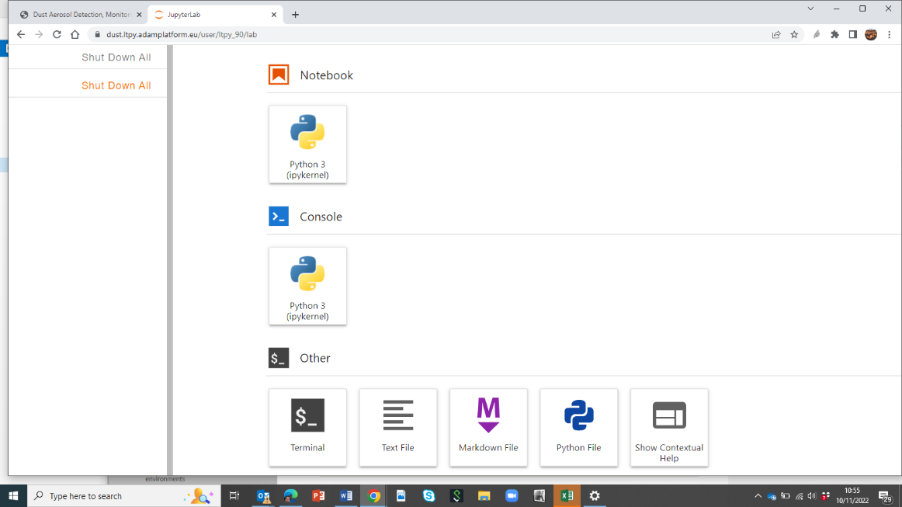
Open the terminal
NOTE: If you already have an environment.yml file in your current directory, it will be overwritten during this task.
Export your active environment to a new file – type in terminal:
conda env export > environment.yml
You can check the content with
cat environment.yml
You can download it from the main page and the use it in your computer

