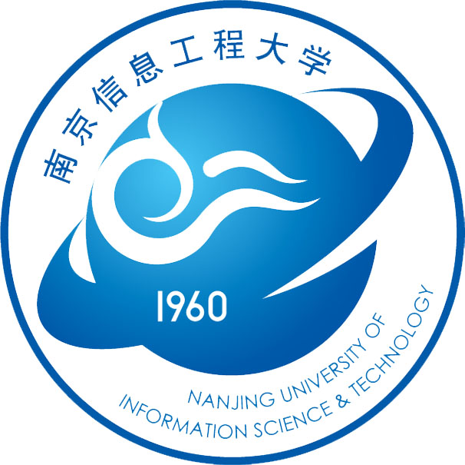Competency Training
for Aeronautical Meteorological Forecasters and Observers
Wang Yong
WMO Regional Training Centre Nanjing, China
Competency training should be productive and meet the needs of trainees. There has been a need for competency training for aeronautical meteorological forecasters and observers in many developing countries/regions according to the implementation guidance of WMO “Aeronautical Meteorological Forecaster and Observer Competency Standards” approved by WMO Cg-XVI in 2011.
In this regard, WMO RTC Nanjing, in collaboration with Macao Meteorological and Geophysical Bureau, has held several bilateral trainings, including four courses for aeronautical meteorological forecasters and three courses for aeronautical meteorological observers and one seminar on WMO and ICAO documents and meteorological knowledge. In addition, we have respectively held two training courses for aeronautical meteorological observers and forecasters from Mozambique and one course for aeronautical meteorological forecasters from Cape Verde.
Experience:
I. Collaborating with regional aviation management authorities and combining the respective advantages of aviation authorities and WMO RTC Nanjing in practice and theory teaching.
II. Target needs survey launched before training. Educational and professional information of participants are collected before the course.
III. Training plan takes training subject, time duration and the target needs into full consideration. And it’s important to balance the teachings in theory and practice, face-to-face teaching and multimedia assisted teaching. Training implementation is based on the classification of trainees with a wide diversity of professional background and educational level from different regions.
IV. RTC Nanjing held bilateral training courses and made specific training programs based on the WMO requirements for training meteorologists/meteorological technicians and the actual situation of the participant’s countries/regions to help the participants to improve their ability of using knowledge to solve practical problems. For parts of training course, by means of written test and submitting reports, participants’ learning results will be quantitatively investigated.
V. In order to provide a reference to improve future training courses, WMO RTC assesses participants’ ability of using knowledge to solve practical problems after attending the training course by contacting their employers.
VI. Training courses are updated with the development of meteorology & hydrology, the new requirements, new strategies and new technologies

Challenges：
I. It is necessary to increase training flexibility to cater to the diversified learning styles and culture of participants.
II. Quantitative assessment with participants is inadequate to reveal the participant competency. There is a need to research into more scientific and effective evaluation (written test, interview, submitting the questionnaire).
III. Limited duration hampers full coverage of essential contents. How to investigate the training requirements of developing countries, especially the least developed countries? On this issue, it is recommended that the WMO-ETRP conducts a questionnaire survey. The results to formulate a long-term strategic planning for the RTCs will have an important guiding significance.
IV. It is difficult to balance the relationship between theory teaching and practice teaching. At present, the solution is to invite meteorological professors on theory teaching from RTC-affiliated University and experts on practice teaching from NHMS. However, trainers often put more emphases on theory than practice. It is difficult for professors and experts from different departments to co-work on theory and practice operations.
V. University professors and NHMS professionals need to develop more awareness and higher motivation for short-term training in compliance with WMO Education and Training Program. How to improve trainers’ professional skills is also a big challenge.
VI. Teaching materials, which are originally catering for academic-degree students need to be adapted to short-term professional training. It is suggested that WMO-ETRP mobilize academic and professional resources to compile corresponding training materials as per the standards of training meteorologists and meteorological technicians for the RTCs.

